Session 3: Implement DDA algorithm (forward) in OpenGL

Intended Learning Outcome:

- Students will be able to implement DDA algorithm (forward).

- Students will be able to draw a line using two endpoints with DDA algorithm.

Expected Skills:

- Calculating any point between two endpoints of a line.

- Clear idea about drawing a line in first coordinate.

Tools Required:

- CodeBlocks

- OpenGL and GLUT using CodeBlocks.

Session Detail:

Line DDA Algorithm:


- The digital differential analyzer(DDA) is a scan conversion line algorithm based on calculation

either Dy or Dx.
- The line at unit intervals is one coordinate and determine corresponding integer values nearest line for the other coordinate.

- Consider first a line with positive slope.

Step: 1

If the slope is less than or equal to 1, the unit x intervals Dx=1 and compute each successive y values.

Dx=1

m = Dy / Dx

m = ( y2-y1 ) / 1

m = ( yk+1 – yk ) /1

yk+1 = yk + m -------- ( 6 )

o Subscript k takes integer values starting from 1, for the first point and increment by 1 until

the final end point is reached.
- m->any real numbers between 0 and 1
- Calculate y values must be rounded to the nearest integer

Step: 2

If the slope is greater than 1, the roles of x any y at the unit y intervals Dy=1 and compute each successive x values.

Dy=1

m= Dy / Dx

m= 1/ ( x2-x1 )

m = 1 / ( xk+1 – xk )

xk+1 = xk + ( 1 / m )------- | ( 7 )

- Equation 6 and Equation 7 that the lines are to be processed from left end point to the right end point.

After getting DDA algorithm’s (forward) concept, students will write a program to implement DDA algorithm.

Code for DDA Algorithm (forward) implementation:


#include <GL/gl.h>

#include <GL/glut.h>

float x1,y1,x2,y2,m,i,j;

int dx=0,dy=0;

void display(void)

{

/* clear all pixels */

glClear (GL_COLOR_BUFFER_BIT);

/* draw white polygon (rectangle) with corners at

- (0.25, 0.25, 0.0) and (0.75, 0.75, 0.0) */

glColor3f (0.0, 1.0, 0.0);

glBegin(GL_POINTS);

if(dx==1){

for(i=x1,j=y1;i<=x2,j<=y2;i=i+1,j=j+m){

glVertex3f ((i/100), (j/100), 0.0);

}

}

else if(dy==1){

for(i=x1,j=y1;i<=x2,j<=y2;i=(i+(1/m)),j=j+1){

glVertex3f ((i/100), (j/100), 0.0);

glVertex3f ((i/100), (j/100), 0.0);

}

}

Copyright © Daffodil International University, 2017 17

Department of Computer Science and Engineering

CSE 422: Computer Graphics Lab Credits: 1.0 Lab Manual v.2017.04

glEnd();

/* don't wait!

- start processing buffered OpenGL routines */

glFlush ();

}

void init (void)

{

/* select clearing (background) color */ glClearColor (0.0, 0.0, 0.0, 0.0);
/* initialize viewing values */ glMatrixMode(GL_PROJECTION); glLoadIdentity();

glOrtho(0.0, 1.0, 0.0, 1.0, -1.0, 1.0); /**

gluOrtho2D(-300, 300, 0, 600);

*/


}

/*

- Declare initial window size, position, and display mode

- (single buffer and RGBA). Open window with "hello"

- in its title bar. Call initialization routines.

- Register callback function to display graphics.

- Enter main loop and process events.

*/

int main(int argc, char** argv)

{

printf("Enter first point: ");

scanf("%f %f",&x1,&y1);

printf("Enter second point: ");

scanf("%f %f",&x2,&y2);

m=(y2-y1)/(x2-x1);

if((x1>x2)&&(y1>y2)){

dx=-1;

}

else{

dx=1;

}

glutInit(&argc, argv);

glutInitDisplayMode (GLUT_SINGLE | GLUT_RGB);

glutInitWindowSize (500, 500);

glutInitWindowPosition (100, 100);

glutCreateWindow ("DDA algorithm implementation");

init ();

glutDisplayFunc(display);

glutMainLoop();

return 0; /* ISO C requires main to return int. */

}

Sample input:

N.B.: (0<=x<100) and (0<=y<100).
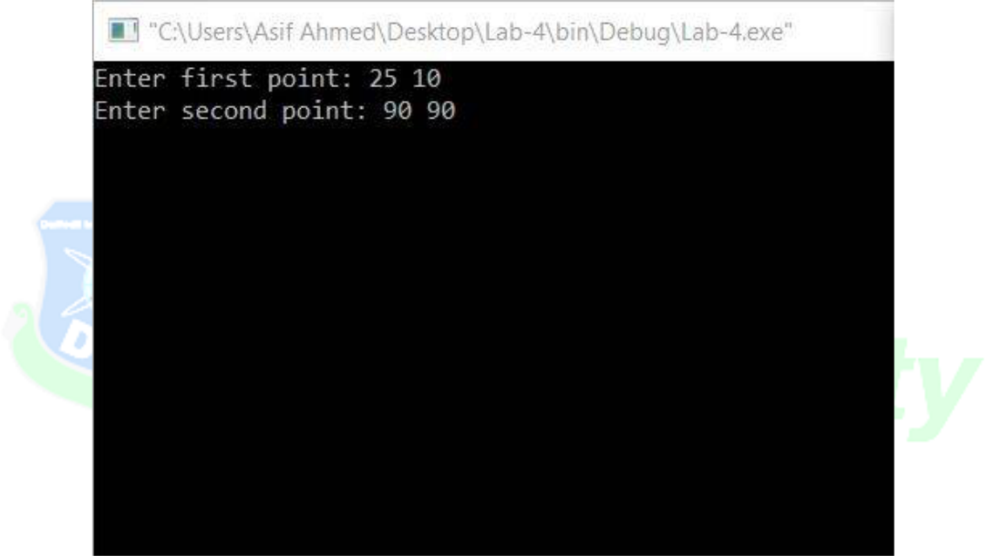

Sample output:
